MAIN EVENTS
How are you living, launching &
pursuing The Dream?
THEME PARTNERS:
Beaver Street Enterprise Center
Business & Entrepreneurship Partner
FSCJ Office of Diversity & Social Change Social Progress Partner
CenCon Cowork
Arts & Creatives Partner
904WARD
Culture & Diversity Partner

DREAMWEEK JAX 2020 occurs January 16 – 25, with a mission to showcase Jacksonville Florida as the Dream City of the millennia in culture, art, business, and social progress. This recognition and celebration of Jacksonville’s evolution as a dream city since its founding in 1562 is long overdue.
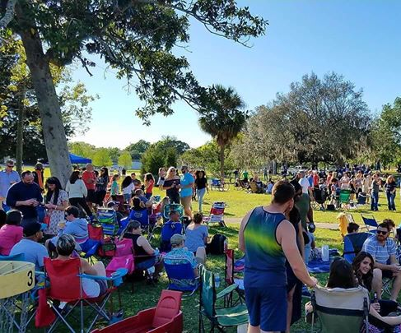
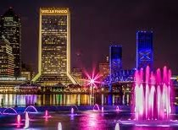

Contact: DREAMWEEK INC,

a nonprofit 501 (c)3 charity
1225 W Beaver Street Jacksonville, FL 32204
Email: dreamteam1@dreamweekjax.org Website: www.dreamweekjax.org
Phone: 904-479-6611 | Social Media: @DREAMWEEKJAX
DAILY FOCUS AREAS
DAY | THEME
Thursday, Jan. 16 & 23 | Focus on Culture & Diversity
Friday, Jan. 17 & 24 | Focus on Social Progress
Saturday, Jan. 18 & 25 | All Themes
Sunday, Jan. 19 | Day of Faith
Monday, Jan. 20 | Day of Service
Tuesday, Jan. 21 | Focus on Arts and Creatives
Wednesday, Jan. 22 | Focus on Business & Entrepreneurship
Social Progress Sub-Themes: women, health, youth, veterans, entrepreneurship, and community safety.

DREAMWEEK JAX 2020 MAIN EVENTS
(For full calendar and partner events, visit www.dreamweekjax.org)

THURSDAY, JAN. 16 – Social Media Day & Partner Expo with Entrepreneur’s DREAM Clinic, Beaver Street Enterprise Center, 10 a.m. – 4 p.m., FREE
FRIDAY, JAN. 17 – Entrepreneur’s DREAM Clinic, Beaver Street Enterprise Center, 10 a.m. – 4 p.m., FREE
SATURDAY, JAN. 18 – PRE-DREAM VIP Mixer, CenCon Cowork, 610 N. Julia Street, 6 p.m. – 8 p.m., $25

SUNDAY, JAN. 19 – DREAMWEEK Soul Sunday Social, Jazzy’s Restaurant & Lounge, noon to 3 p.m., DONATIONS ACCEPTED
SUNDAY, JAN. 19 – WALKER’S LEGACY City Launch Reception, CenCon Cowork, 610 N. Julia Street, 6:30 p.m. – 8 p.m., FREE
MONDAY, JAN. 20 – Historic Stanton, MLK DAY 5K RUN, Downtown Jax., 8 a.m., $25
TUESDAY, JAN. 21 – Artists Gallery & Exhibition, CenCon Cowork, 610 N. Julia Street, Gallery opens 5 p.m., Program 6 p.m. – 8 p.m., $10

WEDNESDAY, JAN. 22 – DreamTellers Reception: Storytelling & Wine, CenCon Cowork, 610 N. Julia Street, 5:30 p.m. – 7 p.m., Tickets $20

THURSDAY, JAN. 23 – 904WARD, Cultural Conversations: The Race Cards Project, Jessie Ball duPont Center, 40 E. Adams Street, 6 p.m. – 8 p.m., FREE

FRIDAY, JAN. 24 – DREAMWEEK SUMMIT, FSCJ Kent Campus, 3939 Roosevelt Blvd, Jacksonville, FL 322059 a.m. – 2 p.m., FREE
SATURDAY, JAN. 25 – DREAMWEEK GATHERING for Women: Self-Care, Wellness & Supportive Spaces, CenCon Cowork, 610 N. Julia Street, 11 a.m. – 3 p.m., FREE

SUBMIT YOUR EVENTS TO DREAMTEAM1@DREAMWEEKJAX.ORG

